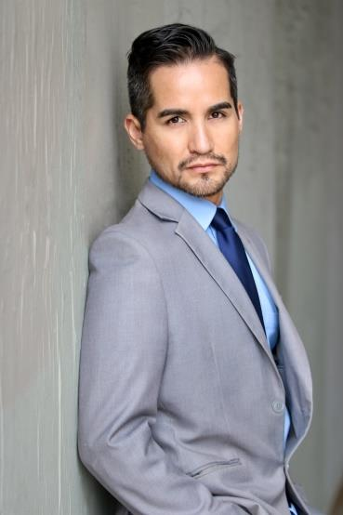
Jay Becerra
www.jaybecerra.com
SAG-AFTRA ELIGIBLE

.

Representation
Prestigious Models
www.prestigiousmodels.com
Los Angeles: (323)451-5929
New York: (212)603-9438

TV
Supreme Justice with Judge Karen Guest Star Entertainment Studios

FILM
Have a good Day Lead Xianyue Wan
The War Within Supporting Marta D’Ocon
Revelations Supporting Cameron Cox

THEATER
A Little Tokyo Christmas Self Aratani Japanese Theater
My Mythology Various The Rosenthal Theater - John Miyasaki
Happily Whatever After King Palace Studios - Chris Bereu
Wonder Women Mr. Miraculous Palace Studios - Rose Olguin
Breathing Time Jack Beverly Hills Play House -Michael Petted
Dog Sees God CB Beverly Hills Play House -Michael Petted
Angeles In America Prior Cypress College - Candice Clasby
Picasso at the Latin Agile Picasso Cypress College - Candice Clasby

TRAINNING
Scene Study Michael Petted Beverly Hills – Playhouse
Scene Study Art Cohan Beverly Hills – Playhouse
On-Camera Technique Candice Clasby Cypress College
Theater I, II Mark Majarian Cypress College

SPECIAL SKILLS
Fluent in Spanish, Tennis, Volleyball, Soccer, Snowboarding, Yoga, Long distance running, Weight training, Martial arts, Cycling, Swimming.

Current Driver’s License (Automatic)
Current USA Passport Exp. 2027
Phone #: 949-572-7978 IG: actorjaybecerra Email: actorjaybecerra@gmail.com

